**Task Description:**

1a.Get me the IP address of a particular domain (guvi.in).

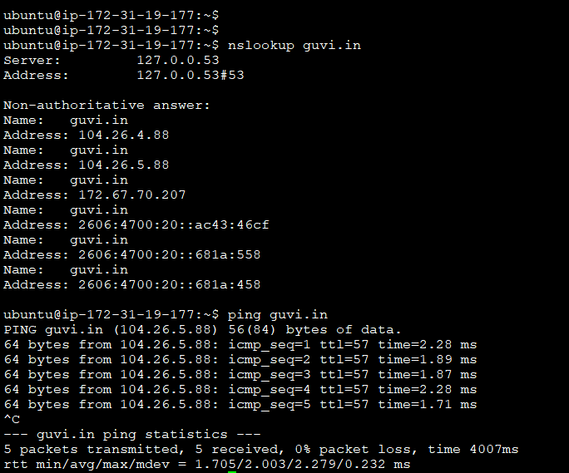

1b. How do I find my CPU/memory usage of my server?



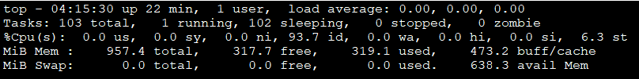

1c. Test the connectivity between 2 nodes?

From either host’s use ping  
e.g   
from host1, ping host2 ipaddress  
from host2, ping host1 ipaddress

2. I have deployed an application in guvi.com:9000, and logs show my app is running, but I’m unable to view the page. Check whether my port is open or not ?

